**Ensembles:**

Ensemblem in ML means using multiple models together.

As we have sever models like SVM, LR, NB. So in ensemble modelling we group them together to obtain a powerful model.

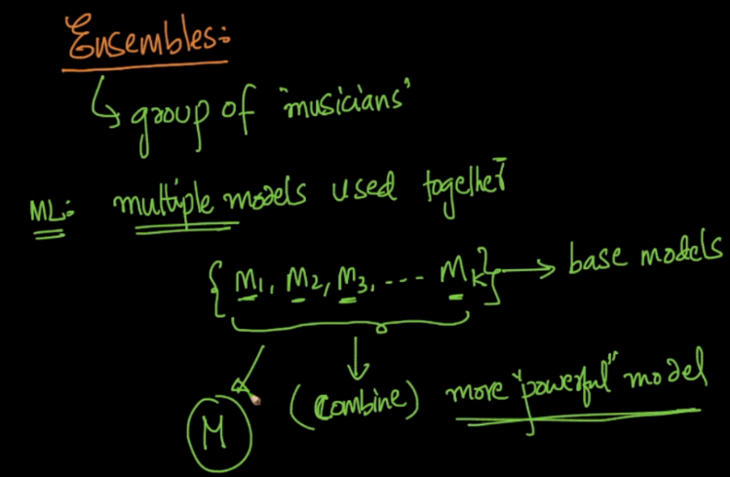

There are many types of Ensemble techniques, 4 of the most used are:

1. Bagging
2. Boosting
3. Stacking
4. Cascading

These techniques are very high performing, powerful and most of Kaggle winners use these. Along with Kaggle it’s used mostly in real world also.

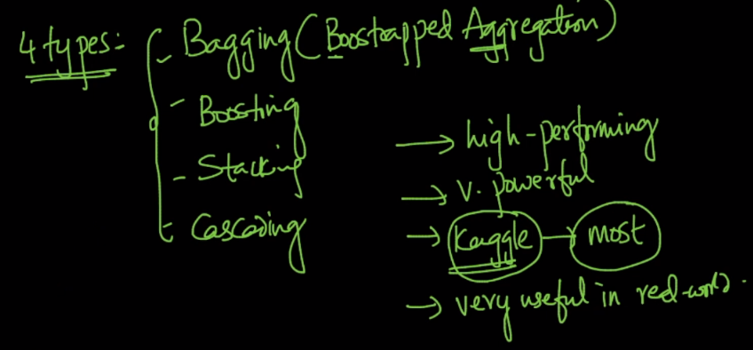

So here one of the aspect of ensemble is that, the more different models we have the more it’s good to combine them.

